STATE OF KANSAS

CAPITOL BUILDING, ROOM 241 SOUTH
Topeka, KS 66612

GOVERNOR LAURA KELLY

EXECUTIVE ORDER NO. 20-20

PHONE: (785) 296-3232
GOVERNOR.KANSAS.GOV

Temporarily allowing notaries and witnesses to act via audio-video communication technology

WHEREAS, securing the health, safety, and economic well-being of residents of the State of Kansas is this Administration's top priority;

WHEREAS, Kansas is facing a crisis-the pandemic and public health emergency of COVID- 19-resulting in illness, quarantines, school closures, and temporary closure of businesses resulting in lost wages and financial hardship to Kansas citizens;

WHEREAS, the United States Departments of Health and Human Services declared a public health emergency for COVID-19 beginning January 27, 2020, with more than 460,000 cases of the illness and more than 16,400 deaths as a result of the illness across the United States;

WHEREAS, the World Health Organization declared a pandemic on March 11, 2020;

WHEREAS, a State of Disaster Emergency was proclaimed for the State of Kansas on March 12, 2020;

WHEREAS, on March 13, 2020, the President of the United States declared the ongoing COVID- 19 a pandemic of sufficient severity and magnitude to warrant an emergency declaration for all states, tribes, territories, and the District of Columbia pursuant to Section 50 1 (b) of the Robert T. Stafford Disaster Relief and Emergency Assistance Act, 42 U.S.C. § 5121-5207 (the “Stafford Act");

WHEREAS, on March 13, 2020, the President of the United States pursuant to Sections 201 and 301 of the National Emergencies Act, 50 U.S.C. § 1601, et seq. and consistent with Section 1135 of the Social Security Act, as amended (42 U.S.C. § 1320b-5), declared a national emergency that
the COVID-19 outbreak in the United States constitutes a national emergency beginning March 1, 2020;

WHEREAS, as of this date, there have been over 1,106 positive cases of COVID-19 in Kansas, spread among 57 counties and 42 deaths as a result of the illness;

WHEREAS, the continued spread of COVID-19 throughout Kansas and the potential for further spread in the days and weeks ahead threatens local health care systems with overload of hospital beds, personal protective equipment, testing and treatment supplies, and other critical resources for responding to the COVID-19 pandemic;

WHEREAS, suspension of certain state statutes and administrative rules is necessary to reduce the risk of further exposure and spread of COVID-19 and to assist with mitigation efforts during the COVID-19 public health emergency;

WHEREAS, throughout the duration of the State of Disaster Emergency, residents of Kansas must continue to make critical personal and business decisions and finalize planning documents that often require the services of a Notary Public or a witness, but pursuant to CDC guidelines and state orders those important in-person interactions should be avoided to the greatest extent possible to prevent the spread of COVID-19;

WHEREAS, Secretary of State Scott Schwab has requested that I issue an executive order relieving notaries and witnesses of certain requirements in light of the COVID-19 pandemic;

WHEREAS, it is necessary and appropriate for the State of Kansas to immediately take measures to promote and secure the safety and protection of the people of the State in response to this COVID-19 outbreak while ensuring that all Kansas residents may continue to make vital personal decisions such as executing a will, power of attorney, or health care directive and business decisions so that businesses may continue to operate and finalize necessary documents during the pandemic; and

WHEREAS, in these challenging times this Administration will do whatever it can to avoid immediate dangers to the health, safety, and welfare of Kansans, including providing guidance and support for local authorities who are making difficult and important decisions to protect the health and safety of their populations, as well as certainty to the broader population that essential functions will not be interrupted.

NOW, THEREFORE, pursuant to the authority vested in me as Governor of the State of Kansas, including the authority granted me by K.S.A 48-924 and K.S.A 48-925, in order to slow the spread of COVID-19, I hereby direct and order the following:

- During the duration of the State of Disaster Emergency related to the outbreak of COVID- 19, the requirements that a person must appear before a Notary Public commissioned under the laws of Kansas pursuant to K.S.A. 53-503 and any related statutes, are suspended and such requirements are satisfied if the Notary Public performs a remote notarization via two­ way audio-video communication technology, provided that:

  - the Notary Public commissioned in Kansas and the individual signing the document are both physically within the State while performing the notarial act;

  - the Notary Public is able to identify the individual signing the document, from personal knowledge or satisfactory evidence of the identity of the individual; and

  - the transaction follows any guidance posted by the Kansas Secretary of State on its website.

- During the duration of the State of Disaster Emergency related to the outbreak of COVID- 19, any act of witnessing required by Kansas law may be completed remotely by two-way audio-video communication technology, provided that:

  - The two-way audio-video communication technology must allow for direct, contemporaneous communication between the individual signing the document ("the signatory") and the witness by sight and sound;

  - The signatory must attest to being physically located in Kansas during the two-way audio-video communication;

  - The witness must attest to being physically located in Kansas during the two-way audio-video communication;

  - The signatory must affirmatively state on the two-way audio-video communication what document the signatory is signing;

  - Each page of the document being witnessed must be shown to the witness on the two-way audio-video communication technology in a means clearly legible to the witness and initialed by the signatory in the presence of the witness;

  - The act of signing must be captured sufficiently up close on the two-way audio­ video communication for the witness to observe;

  - The signatory must transmit by fax or electronic means a legible copy of the entire signed document directly to the witness no later than the day after the document is signed;

  - The witness must sign the transmitted copy of the document as a witness and transmit the signed copy of the document back via fax or electronic means to the signatory within 24 hours of receipt;

1. If necessary, the witness may sign the original signed document as of the date of the original execution by the signatory provided that the witness receives the original signed document together with the electronically witnessed copy within thirty days from the date of the remote witnessing; and

J. If the Notary Public is being asked to certify to the appearance of the witnesses to a document, multiple-way audio-video communication technology must allow for direct, contemporaneous communication between the Notary Public, the signatory, and the witness by sight and sound.

- All provisions of Article 16 of Chapter 16 of the Kansas Statutes Annotated concerning electronic transactions remain in full effect.

- During the duration of the State of Disaster Emergency related to COVID-19, notwithstanding any law or regulation of the State of Kansas to the contrary, absent an express prohibition in a document against signing in counterparts, all legal documents,

Including deeds, last wills and testaments, trusts, durable powers of attorney for property, and powers of attorney for health care, may be signed in counterparts by the witness( es) and the signatory. A Notary Public must be presented with a fax or electronic copy of the document signature pages showing the witness signatures on the same date the document is signed by the signatory if the Notary Public is being asked to certify to the appearance of the witnesses to a document.

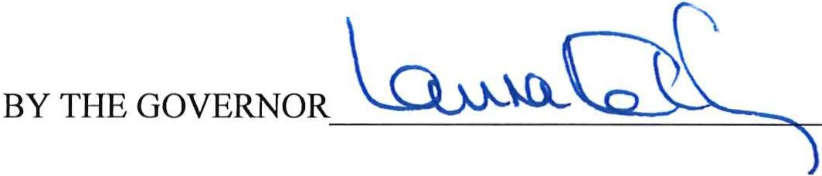This document shall be filed with the Secretary of State as Executive Order No. 20-20. It shall become effective immediately and remain in force until May 1, 2020 or until the statewide State of Disaster Emergency proclaimed on March 12, 2020, relating to COVID-19 expires, whichever is earlier.

THE GOVERNOR'S OFFICE

EO 20-20

DATED 4/9/2020_______

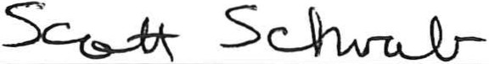
Secretary of State

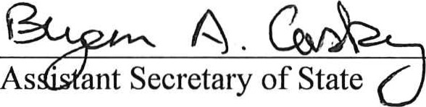

FILED
APR 09 2020
scott SCHWAB SECRETARY OF STATE

4

