Money Laundering & Real Estate

Since January 2016, the Financial Crimes Enforcement Network (FinCEN), required title companies to collect and report beneficial ownership information on certain real estate transactions. These Geographic Targeting Orders apply to all title insurers, their subsidiaries and agents of (“Covered Business”).

* Read FinCEN’s [Advisory](https://www.fincen.gov/sites/default/files/advisory/2017-08-22/Risk%20in%20Real%20Estate%20Advisory_FINAL%20508%20Tuesday%20%28002%29.pdf)
* Read ALTA’s [background article](http://www.alta.org/publications/titlenews/16/v95i02/index.html?utm_source=website&utm_medium=publications&utm_content=list&utm_campaign=DTN_v95i02) & [statement](http://www.alta.org/press/release.cfm?r=266)

*I. The Basics*

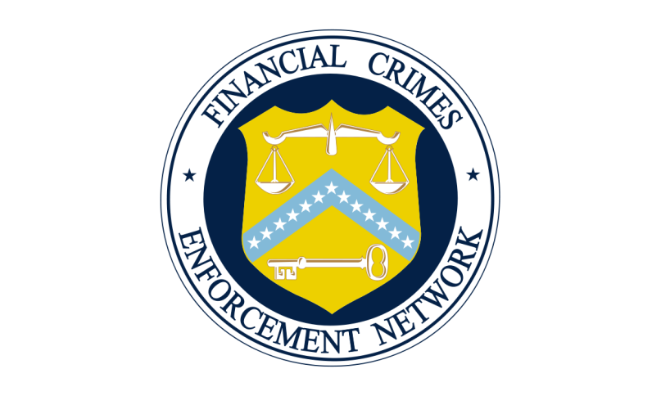**What is FinCEN?**

Established in 1990, FinCEN is a bureau of the U.S. Department of the Treasury. Its mission is “to safeguard the financial system from illicit use and combat money laundering and promote national security through the collection, analysis, and dissemination of financial intelligence and strategic use of financial authorities.” FinCEN fulfills its mission by receiving and maintaining financial transactions data, analyzing and disseminating that data for law enforcement purposes, and building global cooperation with counterpart organizations in other countries and with international bodies. FinCEN’s authority comes from the Currency and Financial Transactions Reporting Act of 1970, as amended by Title III of the USA PATRIOT Act of 2001 and other legislation. This legislative framework is commonly referred to as the Bank Secrecy Act (BSA).

**What is the Bank Secrecy Act?**

The Bank Secrecy Act (BSA) is the primary U.S. anti-money laundering (AML) law and tool for detecting, deterring and disrupting terrorist financing networks. The BSA authorizes the Secretary of the Treasury to issue regulations requiring banks and other financial institutions to take a number of precautions against financial crime, including the establishment of anti-money laundering programs and the filing of reports that have been determined to have a high degree of usefulness in criminal, tax, and regulatory investigations and proceedings, and certain intelligence and counter-terrorism matters. See [**31 U.S.C. 310**](http://www.gpo.gov/fdsys/pkg/USCODE-2010-title31/html/USCODE-2010-title31-subtitleI-chap3-subchapI-sec310.htm).

**What is money laundering?**

Money laundering is the process of disguising financial assets produced through illegal activity. Through money laundering, the monetary proceeds derived from criminal activity are transformed into funds with an apparently legal source.

*II. Geographic Targeting Orders*

**What is a Geographic Targeting Order (GTO)?**

Under the BSA, the director of FinCEN can issue orders imposing additional recordkeeping and reporting requirements on domestic financial institutions or non-financial trades or businesses in a specific geographic area for transactions involving certain amounts of United States currency or monetary instruments. These orders can be in effect for up to 180 days. See 31 U.S.C. § 5326(a); 31 C.F.R. § 1010.370.

**How is a GTO different from cash transaction reporting?**

A cash transaction reporting involves transactions by any business that receives more than $10,000 in currency. Under a GTO, FinCEN can set different thresholds for select business and transactions. Additionally, cash transaction reports are submitted to the IRS, while GTO reports are only sent to FinCEN through their [e-filing system](http://bsaefiling.fincen.treas.gov/main.html).

**Can a GTO be renewed after the initial 180 day period?**

Yes. GTOs can be renewed by the director of FinCEN following a finding that the circumstances justifying the original GTO continue to exist.

**How long does a Covered Business have to report a Covered Transaction to FinCEN?**

A Covered Business must report a Covered Transactionto FinCENwithin thirty (30) days of the closing.

**How long is a Covered Business required to retain Covered Transaction records?**

All records related to compliance with the GTO must be retained for a period of five (5) years from the last day the GTO is effective.

**Will the GTO stop real estate transactions from closing?**

The GTO is not intended to prevent real estate closings from taking place. The GTO is meant to allow the Treasury to collect information about these transactions after the closing.

*III. Legal Requirements for Compliance*

**What are the penalties for violating the GTO?**

Violation of the GTO may subject a Covered Business to the following criminal and civil penalties:

Criminal Penalties

|  |  |
| --- | --- |
| **Type of Violation** | **Penalty** |
| Willful violation | Up to $250,000 fine and 5 years in prison |
| Willful violation while violating another law of the United States | Up to $500,000 fine and 10 years in prison |
| Structuring or assisting in structuring a transaction to avoid the currency transaction reporting | Fine and up to five years in prison |

Civil Penalties

|  |  |
| --- | --- |
| **Type of Violation** | **Penalty** |
| Willful violation  (a separate violation occurs for each day the violation continues and each location a violation occurs) | Greater of the amount involved (up to $100,000) or $25,000 |
| Failure to file a report, material misstatement or omission | Not to exceed the amount involved in the transaction |
| Structuring or assisting in structuring a transaction to avoid the currency transaction reporting | Not to exceed the amount involved in the transaction |
| Negligence | Not to exceed $500 or $50,000 if a pattern of negligence is found |

**Can penalties be assessed against a Covered Business’ individual employees or agents?** Yes. Both civil and criminal penalties may be levied against a partner, director, officer, agent or employee of the Covered Business.

**How long after a violation can the government assess a penalty?**

Penalties can be assessed any time within six years from the date of the Covered Transaction. Civil actions may be commenced within two years of the date of the penalty or criminal conviction.

*IV. Reporting Requirements?*

**Is a title insurance agent, settlement attorney or real estate agent required to report Covered Transactions to FinCEN?**

It depends. The GTO applies to title insurance companies, their subsidiaries and agents. It does not apply to business involved in the Covered Transactions that are not agents of the title insurer, such as attorneys or real estate agents. While the definition of a Covered Business includes the insurer’s agents, only one report is required for each Covered Transaction. Depending on the policy and procedures of the covered insurer, the report can be filed by either the insurer or their agent.

**If the Covered Business just insured the transaction but was not involved in the closing, does it need to report the transaction?**

Yes. A Covered Business must report the transaction whenever it, or its subsidiaries or agents, are involved in the Covered Transaction. This includes when they only provide title insurance and not settlement services in the transactions.

**Can a Covered Business rely on information provided by real estate attorneys or agents when reporting?**Yes. Filers may rely on information collect from the Purchaser, their representative or the Beneficial Owner(s). This includes information collection using the ALTA Information Collection Form

**Can an attorney withhold client information from the title insurance company under a claim of privilege?**

No. Information necessary for completing a GTO Report, Suspicious Activity Report or other Bank Secrecy Act reporting requirement cannot be withheld from the government due to attorney-client privilege. See *United States v. Goldberger & Dublin, P.C.,* 935 F.2d 501 (2nd Cir. 1991), holding that absent special circumstances, attorneys were required to disclose client information on Forms 8300. See also *United States v. Leventhal*, 961 F.2d 936 (11th Cir. 1992), holding that state bar ethical rules do not constitute a “special circumstance” that would protect clients’ names and fee arrangements from disclosure.